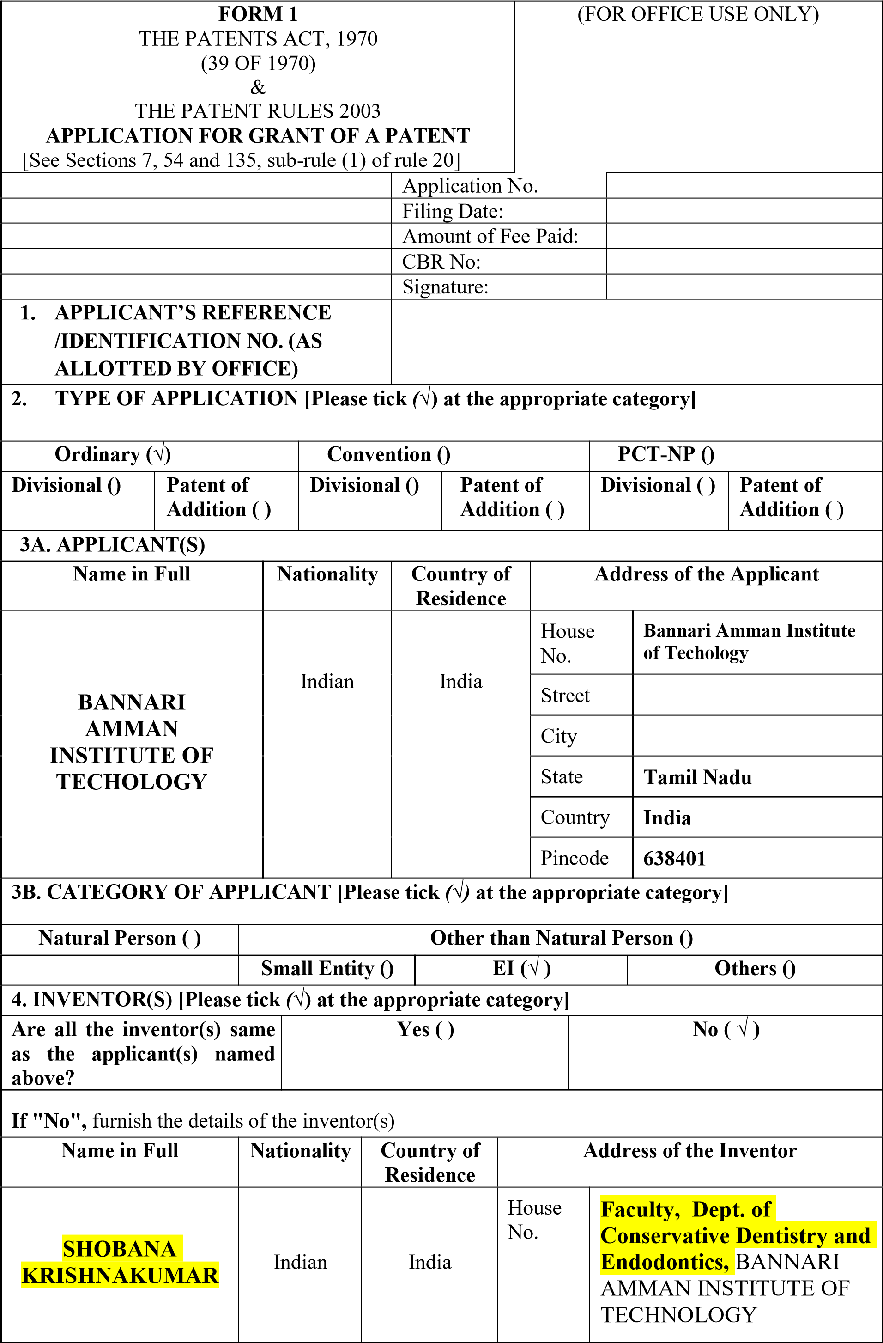

 |  |  | Street | Sathyamangalam
 |  |  | City | Erode
 |  |  | State | Tamil Nadu
 |  |  | Country | India
 |  |  | Pincode | 638401
VENMUGIL RAJAN S | Indian | India | House No.KAYALVIZHI | Faculty, Dept. of  Computer Science and  Engineering, BANNARI  AMMAN INSTITUTE OF  TECHNOLOGY
VENMUGIL RAJAN S | Indian | India | Street | Sathyamangalam
VENMUGIL RAJAN S | Indian | India | City | Erode
VENMUGIL RAJAN S | Indian | India | State | Tamil Nadu
VENMUGIL RAJAN S | Indian | India | Country | India
VENMUGIL RAJAN S | Indian | India | Pincode | 638401
BUVANESH C | Indian | India | House No. | AMMAN INSTITUTE OF  TECHNOLOGY
  Student, Dept. of
  Computer Science and
  Engineering, | BANNARI
BUVANESH C | Indian | India | Street | Sathyamangalam
BUVANESH C | Indian | India | City | Erode
BUVANESH C | Indian | India | State | Tamil Nadu
BUVANESH C | Indian | India | Country | India
BUVANESH C | Indian | India | Pincode | 638401
 | Indian | India | House No. | AMMAN INSTITUTE OF  TECHNOLOGY
  HARISH P
  Student, Dept. of
  Computer Science and
  Engineering, | BANNARI
 | Indian | India | Street | Sathyamangalam
 | Indian | India | City | Erode
 | Indian | India | State | Tamil Nadu
 | Indian | India | Country | India
 | Indian | India | Pincode | 638401

 |  | Indian |  | India |  | House No. |  | AMMAN INSTITUTE OF  TECHNOLOGY
  Student, Dept. of
  Computer Science and
  Engineering, | BANNARI
 |  |  |  |  |  | Street |  | Sathyamangalam
 |  |  |  |  |  | City |  | Erode
 |  |  |  |  |  | State |  | Tamil Nadu
 |  |  |  |  |  | Country |  | India
 |  |  |  |  |  | Pincode |  | 638401
 |  | Indian |  | India |  | House No. |  | AMMAN INSTITUTE OF  TECHNOLOGY
  Student, Dept. of
  Computer Science and
  Engineering, | BANNARI
 |  |  |  |  |  | Street |  | Sathyamangalam
 |  |  |  |  |  | City |  | Erode
 |  |  |  |  |  | State |  | Tamil Nadu
 |  |  |  |  |  | Country |  | India
 |  |  |  |  |  | Pincode |  | 638401
5. TITLE OF THE INVENTION
“AN EMBEDDED EDGE-AI KIOSK APPARATUS AND WIRELESS SENSOR GLOVE SYSTEM FOR REAL-TIME BIDIRECTIONAL SIGN LANGUAGE TRANSLATION USING MULTI-MODAL SENSOR FUSION AND NEURAL INFERENCE”
6. AUTHORIZED REGISTERED  PATENT AGENT(S) |  |  |  |  | IN/PA No. |  | 6111
 |  |  |  |  | Name |  | VINOTH KUMAR J
 |  |  |  |  | Mobile No. |  | 962995576
7. ADDRESS FOR SERVICE  OF APPLICANT IN INDIA |  |  |  |  | Name |  | VINOTH KUMAR J5
 |  |  |  |  | Postal Address |  | IPR cell, BANNARI AMMAN  INSTITUTE OF TECHNOLOGY-  Sathyamangalam,Erode,TamilNadu-  638401
 |  |  |  |  | Telephone |  | 04295-226000
 |  |  |  |  | Mobile No. |  | +91-9629955765;
 |  |  |  |  | Fax No.
 |  |  |  |  | E-mail ID |  | iprcellbit@bitsathy.ac.in
8. IN CASE OF APPLICATION CLAIMING PRIORITY OF APPLICATION FILED IN
CONVENTION COUNTRY, PARTICULARS OF CONVENTION APPLICATION
Country | Application  Number | Filing date | Name of the applicant |  |  | Title of the |  |  | IPC (as classified in the convention country)

 |  |  |  |  | invention
-NA- | -NA- | -NA- | -NA- |  | -NA- | -NA-
9. IN CASE OF PCT NATIONAL PHASE APPLICATION, PARTICULARS OF
INTERNATIONAL APPLICATION FILED UNDER PATENT CO-OPERATION TREATY
(PCT)
International application number |  |  |  | International filing date
-NA- |  |  |  | -NA-
10. IN CASE OF DIVISIONAL APPLICATION FILED UNDER SECTION 16,
PARTICULARS OF ORIGINAL (FIRST) APPLICATION
Original (first) application No. |  |  |  | Date of filing of original (first) application
-NA- |  |  |  | -NA-
11. IN CASE OF PATENT OF ADDITION FILED UNDER SECTION 54, PARTICULARS
OF MAIN APPLICATION OR PATENT
Main application/patent No. |  |  |  | Date of filing of main application
-NA- |  |  |  | -NA-
12. DECLARATIONS
(i) Declaration by the inventor(s)
(In case the applicant is an assignee: the inventor(s) may sign herein below or the applicant may upload the assignment or enclose the assignment with this application for patent or send the assignment by post/electronic transmission duly authenticated within the prescribed period).
I/We, the above-named inventor(s) is/are the true & first inventor(s) for this Invention and declare that the applicant(s) herein is/are my/our assignee or legal representative.

(i). (a) Signature (ii). (a) Signature
(b) Name: (b) Name:
(iii). (a) Signature (iv). (a) Signature (b) Name: (b) Name:
(v). (a) Signature (vi). (a) Signature
(b) Name: (b) Name:
(ii) Declaration by the applicant(s) in the convention country
(In case the applicant in India is different than the applicant in the convention country: the applicant in the convention country may sign herein below or applicant in India may upload the assignment from the applicant in the convention country or enclose the said assignment with this application for patent or send the assignment by post/electronic transmission duly authenticated

within the prescribed period)
I/We, the applicant(s) in the convention country declare that the applicant(s) herein is/are my/our assignee or legal representative.

- Date:
- Signature(s):
- Name(s) of the signatory:
(iii) Declaration by the applicant(s)
I/We the applicant(s) hereby declare(s) that: -
- We are in possession of the above-mentioned invention.
- The provisional/complete specification relating to the invention is filed with this application.
☒ The invention as disclosed in the specification uses the biological material from India and the necessary permission from the competent authority shall be submitted by me/us before the grant of patent to me/us.
☑ There is no lawful ground of objection(s) to the grant of the Patent to me/us.
☒ We are the true & first inventor(s).
☑ We are the assignee or legal representative of true & first inventor(s).
- The application or each of the applications, particulars of which are given in Paragraph-8, was the first application in convention country/countries in respect of my/our invention(s).
- We claim the priority from the above mentioned application(s) filed in convention country/countries and state that no application for protection in respect of the invention had been made in a convention country before that date by me/us or by any person from which I/We derive the title.
- My/our application in India is based on international application under Patent Cooperation Treaty (PCT) as mentioned in Paragraph-9.
- The application is divided out of my /our application particulars of which is given in Paragraph
- 10 and pray that this application may be treated as deemed to have been filed on DDMMYYYY under section 16 of the Act.
- The said invention is an improvement in or modification of the invention particulars of which are given in Paragraph- II.
 | 13. FOLLOWING ARE THE ATTACHMENTS WITH THE APPLICATION
 | (a) Form 2
Item |  |  | Details | Fee | Remarks
Complete Specification |  |  | No. of pages ( 12 ) | 1600/- |  | 12+2+1+4 = 19
No. of Claim(s) |  |  | No. of claims ( 10 ) & No. of pages ( 4 )
Abstract |  |  | No. of pages ( 1 )
No. of Drawing(s) |  |  | No. of drawings ( 4 ) & pages ( 4 )
# In case of a complete specification, if the applicant desires to adopt the drawings filed with his provisional specification as the drawings or part of the drawings for the complete specification under rule 13(4), the number of such pages filed with the provisional specification are required to be mentioned here.
- Complete specification (in conformation with the international application)/as amended before the International Preliminary Examination Authority (IPEA), as applicable (2 copies).
- Sequence listing in electronic form
- Drawings (in conformation with the international app1ication)/as amended before the International Preliminary Examination Authority (IPEA), as applicable (2 copies).
- Priority document(s) or a request to retrieve the priority document(s) from DAS (Digital Access

Service) if the applicant had already requested the office of first filing to make the priority document(s) available to DAS.
- Translation of priority document/Specification/International Search Report/ International Preliminary Report on Patentability.
- Statement and Undertaking on Form 3
- Declaration of Inventorship on Form 5
- Power of Authority
(j)…................................................................................................................
Total fee ₹ 1600 /- (Paid Online) in Cash/ Banker's Cheque /Bank Draft bearing No ...........
Date….. ..............on ............. Bank.
I/We hereby declare that to the best of my/our knowledge, information and belief the fact and matters slated herein are correct and I/We request that a patent may be granted to me/us for the said invention.

Dated this 11th day of October, 2026

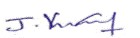
VINOTH KUMAR J

[IN/PA-6111]
Agent for the Applicant
To,
The Controller of Patents
The Patent Office, Kolkata, Mumbai, Delhi, Chennai

